The Senate

Foreign Affairs, Defence and
Trade Legislation Committee
Aspects of the Veterans’ Entitlements Act 1986
and the Military Compensation Scheme

September 2003

© Commonwealth of Australia

ISBN 0 642 71311 1

This document is produced by the Senate Foreign Affairs, Defence and Trade Legislation Committee Secretariat, and printed by the Senate Printing Unit, Parliament House, Canberra.

Senate Foreign Affairs, Defence and Trade
Legislation Committee

Membership

Chair: Senator Sandy Macdonald (NPA, NSW)
Deputy Chair: Senator the Hon Peter Cook (ALP, WA)
Members: Senator Chris Evans (ALP, WA)
Senator Alan Ferguson (LP, SA)
Senator Marise Payne (LP, NSW)
Senator Andrew Bartlett (AD, Qld) substituted for
Aden Ridgeway (AD, NSW)

Participating members
Senator the Hon Eric Abetz (LP, Tas) Senator Steve Hutchins (ALP, NSW)
Senator Mark Bishop (ALP, WA) Senator David Johnston (LP, WA)
Senator the Hon Ron Boswell (NPA, Qld) Senator Sue Knowles, (LP, WA)
Senator George Brandis (LP, Qld) Senator Meg Lees (Ind, SA)
Senator Kim Carr, (ALP, Vic) Senator Ross Lightfoot (LP, WA)
Senator Grant Chapman (LP, SA) Senator Sue Mackay (ALP, Tas)
Senator Jacinta Collins (ALP, Vic) Senator Gavin Marshall (ALP, Vic)
Senator Stephen Conroy (ALP, Vic) Senator Brett Mason (LP, Qld)
Senator Helen Coonan, (LP, NSW) Senator Julian McGauran (NPA, Vic)
Senator Alan Eggleston (LP, WA) Senator Shayne Murphy (Ind, Tas)
Senator the Hon J Faulkner (ALP, NSW) Senator Kerry Nettle (AG, NSW)
Senator Jeannie Ferris (LP, SA) Senator Santo Santoro (LP, Qld)
Senator Michael Forshaw (ALP, NSW) Senator Natasha Stott Despoja (AD, SA)
Senator Brian Harradine (Ind, Tas) Senator Tsebin Tchen (LP, Vic)
Senator Len Harris (PHON, Qld) Senator John Tierney (LP, NSW)
Senator John Hogg (ALP, Qld) Senator John Watson (LP, Tas)

Committee secretariat
Mr Brenton Holmes (Secretary)
Ms Pamela Corrigan
Ms Andrea McAuliffe
Parliament House, Canberra ACT 2600
Phone: (02) 6277 3535, fax: (02) 6277 5818
e–mail: fadt.sen@aph.gov.au; Internet: http://www.aph.gov.au/senate_fadt

Table of contents
Page
Members of the Committee iii
Recommendations vii

Report to the Senate
Chapter 1—Introduction 1
Historical context 2
Chapter 2—The legal framework 5
The Veterans’ Entitlement Act 5
The Safety, Rehabilitation and Compensation Act 5
Issues—Interaction between the VE Act and the SRC Act 7
Approach to compensation 9
Chapter 3—The issues 15
Perceived inequities within the system 15
Recommendation 23
Chapter 4—Conclusions and recommendations 25
Those currently affected 25
Future recipients 26
Recommendation 29
Appendix 1—Submissions received by the Committee 31
Appendix 2—Witnesses who appeared before the Committee 33
Appendix 3—Provisions of the Veterans’ Entitlements Act 1986 35
Appendix 4—Provisions of the Safety, Rehabilitation and Compensation
Act 1988 49
Appendix 5—Definitions 53
Appendix 6—DVA letter to claimants 59
Appendix 7—The Government Actuary’s report to the Committee 63

Recommendations
The Committee recommends:
- that the Department of Veterans’ Affairs ensures that all staff responsible for providing advice on offsetting have access to up to date information and appropriate training;
- that the Department creates a centre of expertise for delivery of expert advice to staff, veterans and widows about the operation of sections 30C and 74 of the Veterans’ Entitlements Act 1986, and for quality assurance on the final calculations of offsets. This will ensure that appropriately trained staff, with the required specialised knowledge, are responsible for making veterans and widows fully aware of their entitlements under the Act; and
- that the Department must ensure that all potential recipients of lump sum compensation understand the implications for their pension of accepting a compensation lump sum; that upon accepting a lump sum, their pension will be offset for life.
The Committee recommends:
- that comprehensive and expert information be given to potential recipients once claims have been accepted, detailing the MCRS lump sum and VE Act pension, with a complete cost schedule, including the rate of offset; and
- that this information be provided to potential recipients before they are required to make a decision about whether to accept a lump sum or a pension. It should also include any other likely payments that will impact on recipients’ future payments (for example, CPI increases).

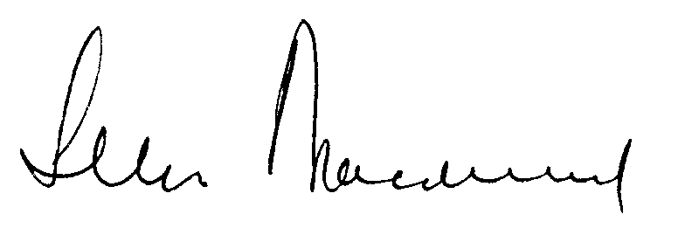

Senator Sandy Macdonald

Chair

